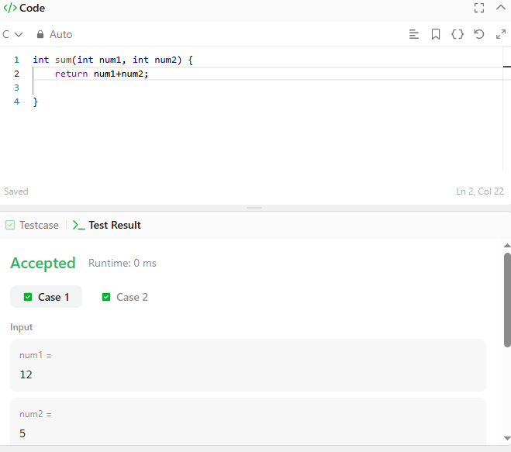

CODE-

int sum(int num1, int num2) {
return num1+num2;

}

LINK-

https://leetcode.com/problems/add-two-integers/

